Objective Questions:
- What is the distribution of account balances across different regions?
Approach :
- The Bank_churn, Customerinfo, and Geography tables were joined to link each customer’s balance with their respective region.
- The data was grouped by region (France, Germany, and Spain) to calculate sum of balances.
Query :
select
g.GeographyLocation as Region,
round(sum(b.Balance),2) as Total_Balance
from bank_churn b
join customerinfo c
on b.CustomerID = c.CustomerID
join geography g
on c.GeographyID = g.GeographyID
group by g.GeographyLocation
order by Total_Balance desc;

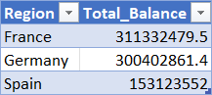

Insights :
- France has the highest total account balance among all regions.
- Germany is a close second, indicating a strong customer deposit base.
- Spain has significantly lower total balances compared to France and Germany.
Recommendations:
- Focus retention strategies on high-value customers in France and Germany.
- Introduce premium banking products in regions with high balances.
- Investigate reasons for lower balances in Spain.

- Identify the top 5 customers with the highest Estimated Salary in the last quarter of the year. (SQL)
Approach :
- Used the customerinfo table.
- Converted the Bank DOJ column from text format (DD/MM/YYYY) to a date using STR_TO_DATE().
- Filtered customers belonging to Quarter 4 (October–December).
- Sorted customers by EstimatedSalary in descending order.
- Retrieved the top 5 records.

Query :
select
CustomerID,
Surname,
EstimatedSalary
from customerinfo
where quarter(str_to_date(`Bank DOJ`,'%d/%m/%y')) = 4
order by EstimatedSalary desc
limit 5;
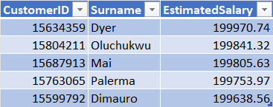

Insights :
- Dyer has the highest estimated salary among Q4 customers.
- All top 5 customers have estimated salaries above 199,600.
- The salary gap among the top 5 customers is very small.
- These customers belong to the bank's high-value customer segment.

Recommendations:
- Offer premium banking services to these customers.
- Target them with wealth management and investment products.
- Focus on retention strategies for high-value customers.
- Use their profile characteristics to identify similar prospects.

- Calculate the average number of products used by customers who have a credit card. (SQL)
Approach :
- Filtered customers who have a credit card (HasCrCard = 1).
- Calculated the average number of products used using AVG().
Query :
select avg(NumOfProducts) as Avg_Products_with_creditcard
from bank_churn
where HasCrCard = 1;

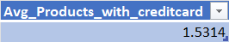

Insights :
- Credit card holders use an average of 1.53 banking products.
- Most credit card customers are using only 1–2 products.
- Product penetration among credit card holders appears moderate.
- There is an opportunity to increase customer engagement through additional products.
Recommendations:
- Cross-sell savings, loans, and investment products to credit card holders.
- Create bundled offers for customers using only one product.
- Target credit card users with personalized product recommendations.
- Increase multi-product adoption to improve customer lifetime value.

- Determine the churn rate by gender for the most recent year in the dataset.
Approach :
- Identified the most recent year in the dataset using max(year(`bank DOJ`)).
- Filtered customers belonging to that year.
- Joined customer, gender and churn data.
- Calculated churn rate for each gender using exited customers divided by total customers.
Query :
Select
g.GenderCategory,
round(sum(case when b.Exited = 1 then 1 else 0 end) * 100.0 / count(*),2)
as churn_rate
from bank_churn b
join customerinfo c
on b.CustomerID = c.CustomerID
join gender g
on c.GenderID = g.GenderID
where year(str_to_date(`Bank DOJ`,'%d/%m/%y')) =
(select max(year(str_to_date(`Bank DOJ`,'%d/%m/%y'))) from customerinfo)
group by g.GenderCategory;

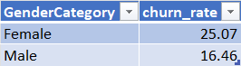

Insights :
- Female customers have a churn rate of 25.07%, the highest among both genders.
- Male customers have a churn rate of 16.46%.
- Female churn is approximately 8.6 percentage points higher than male churn.
- Female customers appear more likely to leave the bank than male customers in the most recent year.
Recommendations:
- Conduct targeted retention campaigns for female customers.
- Analyze reasons behind higher female customer attrition.
- Introduce personalized offers and loyalty programs for female customers.
- Monitor churn trends by gender regularly to evaluate retention strategies.

- Compare the average credit score of customers who have exited and those who remain. (SQL)
Approach :
- Grouped customers based on churn status (Exited or Retained).
- Calculated the average credit score for each group using AVG().
- Compared the average credit score of customers who left the bank versus those who stayed.
Query :
select
case when Exited = 1 then 'Exited' else 'Retained'
end as Customer_Status,
round(avg(CreditScore),2) as Avg_Credit_Score
from bank_churn
group by Exited;

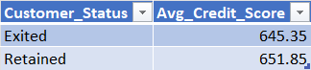

Insights :
- Retained customers have a higher average credit score (651.85) than exited customers (645.35).
- The difference in average credit score is relatively small (6.5 points).
- Customers with slightly stronger credit profiles tend to stay with the bank.
- Credit score alone does not appear to be a major driver of churn.
Recommendations :
- Do not rely solely on credit score for churn prediction.
- Analyse additional factors such as balance, age, geography, and number of products.
- Develop a multi-factor churn prediction model.
- Focus retention efforts on customers showing multiple churn-risk indicators rather than only low credit scores.

- Which gender has a higher average estimated salary, and how does it relate to the number of active accounts? (SQL)
Approach :
- Joined customerinfo, gender, and bank_churn tables.
- Calculated average estimated salary by gender.
- Counted active accounts using IsActiveMember.
- Compared salary levels with active account counts.

Query :
select
g.GenderCategory,
round(avg(c.Estimatedsalary),2) as Avg_Estimated_salary,
sum(b.IsActiveMember) as Active_Accounts
from customerinfo c
join gender g
on c.GenderID = g.GenderId
join bank_churn b
on c.CustomerID = b.CustomerID
group by g.GenderCategory;

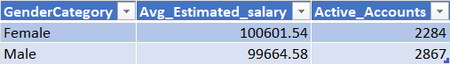

Insights :
- Female customers have a slightly higher average estimated salary (100,601.54) compared to male customers (99,664.58).
- Male customers have more active accounts (2,867) than female customers (2,284).
- The salary difference between genders is relatively small (less than 1%).
- Higher average salary does not necessarily correspond to a higher number of active accounts.
Recommendations :
- Analyse factors other than salary that drive account activity, especially among female customers.
- Create targeted engagement campaigns to increase active account usage among high-income female customers.
- Offer personalized banking products based on customer activity patterns rather than salary alone.
- Further investigate demographic and behavioural factors influencing account activation and usage.

- Segment the customers based on their credit score and identify the segment with the highest exit rate. (SQL)
Approach :
- Segmented customers into three groups based on Credit Score:
-Low: < 600
-Medium: 600–699
-High: ≥ 700
- Calculated the churn (exit) rate for each segment.
- Compared the exit rates to identify the most vulnerable segment.
Query :
select
case when CreditScore < 600 then 'Low'
when creditscore between 600 and 700 then 'Medium'
else 'High'
end as Credit_Segment,
round(sum(case when Exited = 1 then 1 else 0 end) * 100.0 / count(*),2)
as Exit_Rate
from bank_churn
group by Credit_Segment
order by Exit_Rate desc

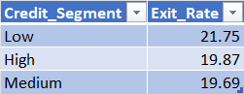

Insights :
- Low credit score customers have the highest exit rate (21.75%) among all segments.
- Customers in the High credit score segment show a lower churn rate (19.87%) than the Low segment.
- The Medium segment has the lowest churn rate (19.69%).
- Lower credit scores appear to be associated with a greater likelihood of customer churn.
Recommendations :
- Develop retention programs specifically for low-credit-score customers, as they are most likely to leave.
- Offer personalized financial guidance and credit improvement benefits to reduce churn.
- Monitor low-score customers more closely through early-warning churn models.
- Create loyalty incentives and tailored banking products for at-risk customer segments.
- Find out which geographic region has the highest number of active customers with a tenure greater than 5 years. (SQL)
Approach :
- Filtered customers with Tenure > 5 years and IsActiveMember = 1.
- Joined customer and geography tables to identify customer regions.
- Counted active customers in each region.
- Ranked regions based on the number of active customers.
Query :
select
g.GeographyLocation as Region,
count(*) as Active_Customers
from bank_churn b
join customerinfo c
on b.CustomerID = c.CustomerID
join geography g
on c.GeographyID = g.GeographyID
where b.IsActiveMember = 1
and b.Tenure > 5
group by g.GeographyLocation
order by Active_Customers desc;

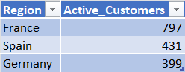

Insights :
- France has the highest number of active customers with tenure greater than 5 years (797 customers).
- France has nearly double the number of long-tenure active customers compared to Germany.
- Spain ranks second with 431 active customers.
- The results indicate stronger customer retention and engagement in France.
Recommendations :
- Analyse customer retention strategies used in France and replicate successful practices in other regions.
- Launch targeted loyalty programs in Germany and Spain to improve long-term customer engagement.
- Investigate factors contributing to France's higher customer retention, such as product adoption or customer service quality.
- Focus on retaining high-tenure customers, as they represent a stable and valuable customer segment.

- What is the impact of having a credit card on customer churn, based on the available data?
Approach :
- Segmented customers into two groups:
-Customers with a credit card (HasCrCard = 1)
-Customers without a credit card (HasCrCard = 0)
- Calculated the churn rate for each group.
- Compared the churn percentages to evaluate the impact of credit card ownership on customer retention.
Query :
select
case
when HasCrCard = 1 then 'Has Credit Card'
else 'No Credit Card'
end as Credit_Card_Status,
round(sum(case when Exited = 1 then 1 else 0 end) * 100.0 / count(*),2)
as churn_rate
from bank_churn
group by HasCrCard;

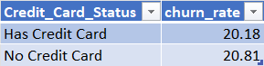

Insights :
- Customers without a credit card have a slightly higher churn rate (20.81%) than customers with a credit card (20.18%).
- The difference in churn rates is very small (0.63 percentage points).
- Credit card ownership alone does not appear to be a strong predictor of customer churn.
- Both groups experience a similar level of churn, suggesting that other factors may have a greater influence on customer retention.
Recommendations :
- Do not rely solely on credit card ownership as a churn prevention strategy.
- Investigate other factors such as customer activity, tenure, balance, and satisfaction levels to better understand churn behaviour.
- Bundle credit cards with loyalty rewards and personalized benefits to increase customer engagement.
- Use multi-factor churn analysis models instead of focusing only on credit card status.

- For customers who have exited, what is the most common number of products they have used?
Approach :
- Filtered customers where Exited = 1.
- Grouped customers by NumOfProducts.
- Counted the number of exited customers in each product category.
- Identified the product count with the highest frequency.
Query :
select
NumOfProducts,
count(*) as Customer_Count
from bank_churn
where Exited = 1
group by NumOfProducts
order by Customer_Count desc;

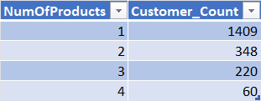

Insights :
- Customers with 1 product represent the largest group of churned customers (1,409).
- The number of churned customers decreases significantly as the number of products increases.
- Customers using multiple products appear to be more engaged with the bank.
- Customers with 4 products have the lowest churn count (60 customers).
Recommendations :
- Encourage customers with only one product to adopt additional banking products.
- Create cross-selling campaigns targeting single-product customers.
- Develop loyalty programs that reward customers for using multiple products.
- Monitor single-product customers closely, as they appear to be the most vulnerable segment.

- Examine the trend of customers joining over time and identify any seasonal patterns (yearly or monthly). Prepare the data through SQL and then visualize it.
Approach :
- Converted Bank DOJ from text to date using STR_TO_DATE().
- Extracted year and month from joining dates.
- Counted customers joining in each period.
- Analysed monthly distribution to identify seasonal trends.
Query :
/*Yearly Analysis*/
select
year(str_to_date(`Bank DOJ`, '%d/%m/%y')) as join_year,
count(*) as customers_joined
from customerinfo
group by join_year
order by join_year;

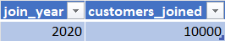

/*Monthly Analysis*/
select
year(str_to_date(`Bank DOJ`, '%d/%m/%y')) as join_year,
month(str_to_date(`Bank DOJ`,'%d/%m/%y')) as join_month,
count(*) as customers_joined
from customerinfo
group by join_year,join_month
order by join_year,join_month;

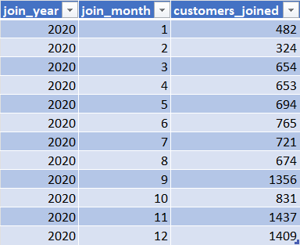

Insights :
- All 10,000 customers in the dataset joined in 2020, indicating that the available data covers only one year.
- November (1,437 customers) and December (1,409 customers) recorded the highest customer acquisitions.
- September (1,356 customers) also showed a significant increase in customer onboarding.
- February (324 customers) had the lowest number of customer joins.
- Customer acquisition was strongest during Q4 (October–December), suggesting possible seasonal demand.

Recommendations :
- Collect multi-year customer joining data to enable meaningful yearly trend analysis.
- Investigate the business activities or campaigns conducted during September–December and replicate successful strategies.
- Increase marketing efforts during low-performing months such as January and February.
- Prepare additional onboarding and support resources during Q4 when customer acquisition peaks.
- Use monthly seasonality patterns to improve forecasting and customer acquisition planning.
- Analyze the relationship between the number of products and the account balance for customers who have exited.
Approach :
- Filtered the dataset to include only customers who have exited.
- Grouped customers based on the number of products they used.
- Calculated the average account balance for each product group.
- Compared the average balances to understand the relationship between product usage and account balance among exited customers.
Query :
select
NumOfProducts,
round(avg(Balance),2) as Avg_Balance
from bank_churn
where Exited = 1
group by NumOfProducts
order by NumOfProducts;

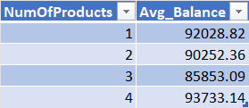

Insights :
- Customers with 4 products had the highest average balance before exiting, at 93,733.14.
- Customers with 3 products had the lowest average balance, averaging 85,853.09.
- The average balances for exited customers across all product segments remain relatively high (85K–94K range), indicating that many churned customers still held significant funds with the bank.
- There is no clear linear relationship between the number of products and account balance:
-Balance decreases from 1 to 3 products.
-Then increases sharply for customers with 4 products.
- Having more products does not necessarily guarantee customer retention, as even customers with multiple products and high balances exited.

Recommendations :
- Identify and monitor high-balance customers with multiple products, especially those holding 4 products, as their churn can result in significant revenue loss.
- Create personalized retention campaigns for customers with:
  - High balances
  - Multiple products
  - Reduced engagement signals
- Conduct further analysis combining:
  - Product count
  - Balance
  - Credit score
  - Active membership status
to understand why valuable customers are leaving.
- Offer loyalty benefits, premium support, or relationship-manager programs for high-value multi-product customers.

- Identify any potential outliers in terms of balance among customers who have remained with the bank.
Approach :
- Filtered the dataset to include only retained customers (Exited = 0).
- Calculated the average balance and standard deviation of balances.
- Identified customers whose balances exceed Average Balance + 2 × Standard Deviation.
- Analysed these customers as potential balance outliers.
Query :
select
CustomerID,
Balance
from bank_churn
where Exited = 0
and Balance > ( select
avg(Balance)+2 * stddev(Balance)
from bank_churn
where Exited = 0)
order by Balance desc;

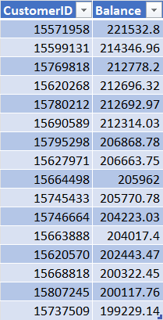

Insights :
- Several retained customers have exceptionally high balances exceeding the normal balance range.
- The highest retained customer balance is approximately 221,533.
- These customers represent high-value accounts and differ significantly from the average retained customer.
- The bank has successfully retained some of its most valuable customers.
Recommendations :
- Create VIP retention programs for high-balance customers.
- Assign relationship managers to premium customers.
- Monitor engagement and satisfaction of these customers regularly.
- Offer personalized banking benefits to maintain long-term relationships.

- How many different tables are given in the dataset, out of these tables which table only consists of categorical variables?
Total Number of Tables:
There are seven tables present in the dataset:
1. ActiveCustomer
2. Bank_Churn
3. CreditCard
4. CustomerInfo
5. ExitCustomer
6. Gender
7. Geography

Tables Containing Only Categorical Variables:
The following tables consist entirely of categorical variables, which represent descriptive or classification-type data:
● Gender – contains the column GenderCategory (e.g., Male, Female).
● Geography – includes GeographyLocation (e.g., France, Germany, Spain).
● ExitCustomer – has ExitCategory (e.g., Exit, Retain).
● ActiveCustomer – features ActiveCategory (e.g., Active Member, Inactive Member).
● CreditCard – includes Category (e.g., Credit-card holder, Non-Credit card holder).

- Using SQL, write a query to find out the gender-wise average income of males and females in each geography id. Also, rank the gender according to the average value. (SQL)
Approach :
- Joined CustomerInfo, Gender, and Geography tables.
- Calculated the average estimated salary for each gender in each geography.
- Used the RANK() function to rank genders based on average income within each geography.
- Compared income patterns across France, Germany, and Spain.
Query :
select
geo.GeographyLocation,
g.GenderCategory,
round(avg(c.EstimatedSalary),2) as Avg_Income,
rank() over(partition by geo.GeographyLocation
order by avg(c.EstimatedSalary) desc) as Gender_Rank
from customerinfo c
join gender g
on c.GenderID = g.GenderID
join geography geo
on c.GeographyID = geo.GeographyID
group by geo.GeographyLocation, g.GenderCategory;

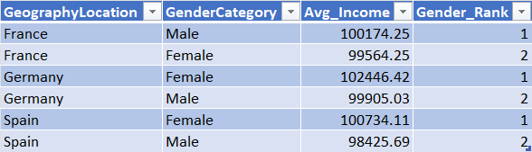

Insights :
- France: Male customers have the highest average income (100,174.25) and rank 1.
- Germany: Female customers have the highest average income (102,446.42) and rank 1.
- Spain: Female customers have the highest average income (100,734.11) and rank 1.
- Female customers rank first in 2 out of 3 regions.
- Germany has the highest average income among all geography-gender combinations.
Recommendations :
- Target high-income female customers in Germany and Spain with premium banking products.
- Design region-specific marketing campaigns rather than a single strategy for all geographies.
- Further analyse whether higher-income customer segments have lower churn rates to improve retention strategies.

- Using SQL, write a query to find out the average tenure of the people who have exited in each age bracket (18-30, 30-50, 50+).
Approach :
- Filtered only customers who have exited the bank.
- Divided customers into three age groups: 18–30, 30–50, and 50+.
- Calculated the average tenure for each age bracket.
- Compared tenure values across age groups to identify patterns.
Query :
select
case
when Age >= 18 and Age < 30 then '18-30'
when Age >= 30 and Age <= 50 then '30-50'
else '50+'
end as age_bracket,
round(avg(b.Tenure),2) as avg_tenure
from customerinfo c
join bank_churn b
on c.CustomerID = b.CustomerID
where b.Exited = 1
group by age_bracket;
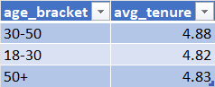

Insights :
- Customers aged 30–50 have the highest average tenure before exiting (4.88 years).
- Customers aged 50+ have an average tenure of 4.83 years.
- Customers aged 18–30 have the lowest average tenure before exiting (4.82 years).
- The differences are very small (less than 0.1 year), indicating that tenure before churn is fairly consistent across age groups.
Recommendations :
- Since tenure is almost the same across all age groups, age alone does not appear to be a strong driver of customer exits.
- The bank should investigate other factors such as account activity, balance, credit score, and product usage to better understand churn behavior.
- Retention strategies should focus on customer engagement rather than age-specific tenure patterns.

- Is there any direct correlation between salary and the balance of the customers? And is it different for people who have exited or not?
Approach :
- Compared the average salary of exited and retained customers.
- Compared the average account balance of exited and retained customers.
- Analysed whether higher salary is associated with higher account balances.
- Checked if the relationship differs between exited and retained customers.
Query :
select
Exited,
round(avg(EstimatedSalary),2) as avg_salary,
round(avg(Balance),2) as avg_balance
from customerinfo c
join bank_churn b
on c.CustomerID = b.CustomerID
group by Exited;

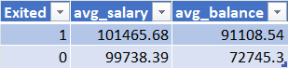

Insights :
- Exited customers have an average salary of 101,465.68, while retained customers have an average salary of 99,738.39.
- Exited customers maintain a higher average balance (91,108.54) compared to retained customers (72,745.30).
- The chart suggests a positive relationship between salary and balance, as both metrics move in the same direction.
- Despite having higher salaries and balances, these customers still left the bank, suggesting that salary and balance alone do not determine customer retention.
Recommendations :
- Do not rely solely on salary to predict customer churn.
- Focus on retaining high-balance customers, as they represent significant business value.
- Analyse additional factors such as tenure, number of products, geography, and activity status to understand churn behaviour.
- Create targeted retention strategies for high-income and high-balance customers who may be at risk of leaving.

- Is there any correlation between the salary and the Credit score of customers?
Approach :
- Segmented customers into Low, Medium, and High credit score groups.
- Calculated the average salary for each segment.
- Compared salary levels across the segments.
- Analysed whether higher credit scores were associated with higher salaries.
Query :
select
case
when CreditScore < 600 then 'Low'
when CreditScore between 600 and 700 then 'Medium'
else 'High'
end as credit_segment,
round(avg(EstimatedSalary),2) as avg_salary
from customerinfo c
join bank_churn b
on c.CustomerID = b.CustomerID
group by credit_segment;

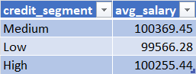

Insights :
- The average salaries across all three credit score segments are extremely close.
- The difference between the highest and lowest average salary is only about ₹803.
- Customers with High credit scores do not earn significantly more than customers with Low credit scores.
- The pattern is not increasing consistently from Low → Medium → High.
Recommendations :
- Focus on improving customer financial behaviour and engagement rather than targeting customers based on salary levels.
- Design customer retention and credit-risk strategies using behavioural indicators such as transaction history, account activity, and product usage.
- Further analysis can be conducted on factors that may have a stronger influence on credit score than salary.

- Rank each bucket of credit score as per the number of customers who have churned the bank.
Approach :
- Segmented customers into Low, Medium, and High credit score buckets.
- Filtered only churned customers (Exited = 1).
- Counted churned customers in each bucket.
- Ranked the segments based on churn count.
Query :
select
case
when CreditScore < 600 then 'Low'
when CreditScore between 600 and 700 then 'Medium'
else 'High'
end as credit_segment,
count(*) as churned_customers,
rank() over(order by count(*) desc) as segment_rank
from bank_churn
where Exited = 1
group by credit_segment;

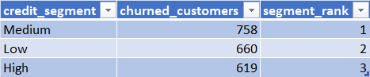

Insights :
- The Medium credit score segment recorded the highest number of churned customers (758).
- The Low credit score segment ranked second with 660 churned customers.
- The High credit score segment had the lowest churn count (619).
- Most customer churn is concentrated in the Medium credit score group.
Recommendations :
- Investigate the Medium credit score segment further to understand the key reasons for customer exits.
- Design targeted retention campaigns for Medium-score customers, as they represent the largest churn volume.
- Monitor this segment regularly to identify early warning signs of churn and improve customer engagement.

- According to the age buckets find the number of customers who have a credit card. Also retrieve those buckets that have lesser than average number of credit cards per bucket.
Approach :
- Divided customers into age buckets (18–30, 30–50, and 50+).
- Counted customers who own a credit card in each bucket.
- Calculated the average credit card holders across all age buckets.
- Identified buckets with credit card counts below the average.
Query :
with age_bucket_data as (
select
case
when Age >= 18 and Age <30 then '18-30'
when Age >= 30 and Age <= 50 then '30-50'
else '50+'
end as age_bucket,
count(*) as credit_card_customers
from customerinfo c
join bank_churn b
on c.CustomerID = b.CustomerID
where HasCrCard = 1
group by age_bucket)
select * from age_bucket_data
where credit_card_customers < (select avg(credit_card_customers)
from age_bucket_data);
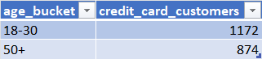

Insights :
- The 50+ age group has the lowest number of credit card holders (874).
- The 18–30 age group also falls below the average with 1172 credit card holders.
- The 30–50 age group is the only segment above the average, indicating stronger credit card adoption among middle-aged customers.
- Credit card ownership appears to be concentrated in the 30–50 age bracket.
Recommendations :
- Create targeted credit card campaigns for younger customers (18–30) using student, travel, or cashback benefits.
- Introduce simple and reward-focused credit card offerings for customers aged 50+.
- Analyse customer preferences in the 18–30 and 50+ groups to understand barriers to credit card adoption.
- Focus future marketing efforts on age segments with lower penetration to improve overall credit card usage.

- Rank the Locations as per the number of people who have churned the bank and average balance of the customers.
Approach :
- Group customers by geographic location.
- Count the number of customers joined from each location.
- Calculate the average balance for customers in each location.
- Rank locations based on customer count and average balance.
Query :
select
g.GeographyLocation as Location,
count(*) as Customers_joined,
round(avg(b.Balance),2) as avg_balance,
rank() over(order by count(*) desc) as customer_rank,
rank() over(order by avg(b.Balance) desc) as balance_rank
from customerinfo c
join geography g
on c.GeographyID = g.GeographyID
join bank_churn b
on c.CustomerID = b.CustomerID
group by g.GeographyLocation;

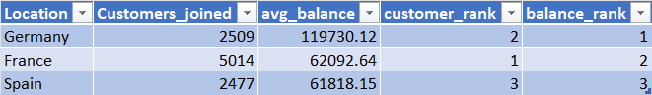

Insights :
- France ranks 1st in customer acquisition with 5,014 customers, indicating the strongest customer base among all regions.
- Germany ranks 1st in average balance with 119,730.12, despite having only 2,509 customers.
- Spain has the lowest customer count (2,477) and lowest average balance (61,818.15) among the three locations.
- The region with the most customers is not necessarily the region with the highest customer value. Germany demonstrates higher customer value despite a smaller customer base.
Recommendations :
- Investigate Germany's customer profile and banking products to understand why customers maintain significantly higher balances.
- Focus on increasing customer acquisition in Germany, as it combines strong customer value with growth potential.
- Develop targeted engagement campaigns in Spain to improve both customer acquisition and balance retention.
- Continue customer acquisition efforts in France while introducing strategies to increase average balances per customer.

- As we can see that the “CustomerInfo” table has the CustomerID and Surname, now if we have to join it with a table where the primary key is also a combination of CustomerID and Surname, come up with a column where the format is “CustomerID_Surname”.
Approach :
- Used the CustomerID and Surname columns from customerinfo.
- Concatenated them with an underscore (_).
- Created a new column that can be used as a composite key for joining with another table.
Query :
select
CustomerID,
Surname,
concat(CustomerID, '_', Surname) as Customer_Key
from customerinfo;

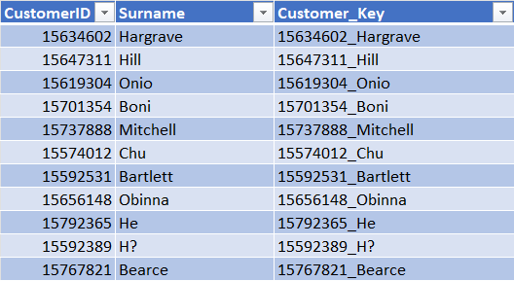

- Without using “Join”, can we get the “ExitCategory” from ExitCustomers table to Bank_Churn table? If yes do this using SQL.
Approach :
- Used the Exited column from bank_churn.
- Used a subquery to look up the corresponding ExitCategory from exitcustomer.
- Matched Exited with ExitID.
Query :
select
b.CustomerID,
b.Exited,
(select
ExitCategory
from exitcustomer e
where e.ExitID = b.Exited) as ExitCategory
from bank_churn b;

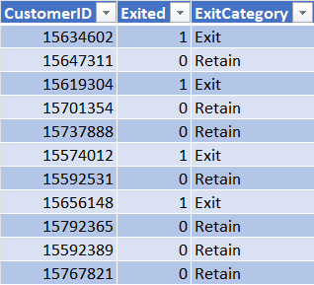

- Were there any missing values in the data, using which tool did you replace them and what are the ways to handle them?
Approach :
- Loaded all tables into Power BI.
- Used Power Query Editor to inspect each column for null or blank values.
- Checked data quality and data profiling to identify missing records.
- Cleaned the data before building relationships and visuals.
Tool Used :
Power Query Editor

Insights :
- No significant missing values were found in the dataset.
- All required fields were populated, so no data imputation or replacement was necessary.
Ways Missing Values Can Be Handled (If Present) :
- Remove rows containing null values.
- Replace with Mean/Median (numerical columns).
- Replace with Mode (categorical columns).
- Fill Down / Fill Up.
- Replace with "Unknown" or "Not Available".

- Write the query to get the customer IDs, their last name, and whether they are active or not for the customers whose surname ends with “on”.
Approach :
- Joined customerinfo and bank_churn using CustomerID.
- Used the LIKE '%on' pattern to filter surnames ending with "on".
- Used a CASE statement to classify customers as Active or Inactive.
Query :
select
c.CustomerID,
c.Surname,
case
when b.IsActiveMember = 1 then 'Active'
else 'Inactive'
end as active_status
from customerinfo c
join bank_churn b
on c.CustomerID = b.CustomerID
where c.Surname like '%on';

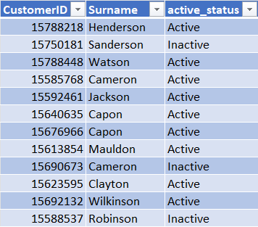

Insights :
- Multiple customers have surnames ending with "on", such as Henderson, Sanderson, Watson, Cameron, Jackson, Robinson, and Stevenson.
- Both Active and Inactive customers are present in this group.

- Can you observe any data disrupency in the Customer’s data? As a hint it’s present in the IsActiveMember and Exited columns. One more point to consider is that the data in the Exited Column is absolutely correct and accurate.
Approach :
I compared the Exited and IsActiveMember columns to identify customers who are marked as exited but are still classified as active members.
Query :
select
count(*) as Disrupency
from bank_churn
where Exited = 1 and IsActiveMember = 1;

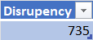

Insights :
- There are 735 customers who have exited the bank but are still marked as active members.
- Since the Exited column is stated to be accurate, the inconsistency likely exists in the IsActiveMember column.
- This indicates a data quality issue where active membership status may not have been updated after customer exit.
Recommendations :
- Validate the business definition of "Active Member."
- Review the process that updates customer status after churn.
- Implement validation checks to ensure exited customers are not incorrectly marked as active.

Subjective Question:

- Customer Behavior Analysis: What patterns can be observed in the spending habits of long-term customers compared to new customers, and what might these patterns suggest about customer loyalty?
Approach : Analyzed the relationship between customer tenure (3–7 years) and average account balance using a clustered column chart to understand how spending behavior changes with customer tenure.

DAX Queries :
Average Balance = AVERAGE(Bank_Churn[Balance])
Visualizations :

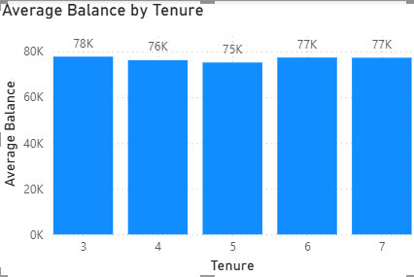
Insights :
- Customers with 3 years of tenure have the highest average balance (~78K).
- Customers with 5 years of tenure have the lowest average balance (~75K).
- Customers with 6–7 years of tenure maintain an average balance of around 77K, indicating stable financial engagement.
- The variation in average balance across tenure groups is very small (approximately 3K), suggesting that spending behaviour remains fairly consistent regardless of how long customers have stayed with the bank.
- There is no strong evidence that longer-tenure customers maintain significantly higher balances than newer customers.
Recommendations :
- Introduce loyalty rewards and premium banking benefits for customers with higher tenure to encourage larger balances.
- Launch personalized investment or savings offers for long-term customers to increase wallet share.
- Monitor customers whose balances decline over time and engage them through targeted retention campaigns.
- Combine tenure analysis with other factors such as credit score, active membership, and product ownership to identify high-value loyal customers more accurately.

- Product Affinity Study: Which bank products or services are most commonly used together, and how might this influence cross-selling strategies?
Approach :
- Analyzed customer product ownership by examining the relationship between the number of products owned, credit card ownership, and active membership.
- Clustered column, stacked bar, and donut charts were used to identify common product combinations and customer engagement patterns.
DAX Queries :
Customer Count = COUNT(CustomerInfo[CustomerId])
Visualizations :

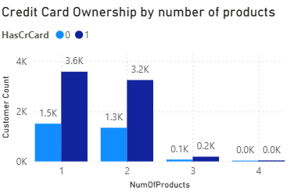

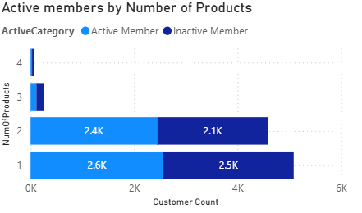

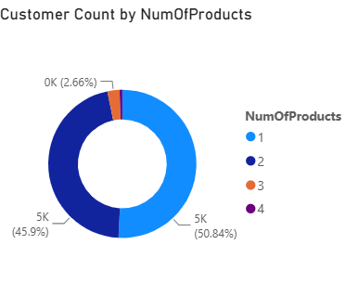
Insights :
- Most customers own 1 or 2 banking products, accounting for nearly the entire customer base.
- Customers with one product represent the largest segment (around 51%), followed closely by customers with two products (around 46%).
- A majority of customers owning one or two products also have a credit card, indicating that credit cards are frequently bundled with core banking products.
- Very few customers own three or four products, suggesting limited adoption of additional banking services.
- Active and inactive customers are present across both one-product and two-product segments, indicating opportunities to increase engagement through targeted product offerings.
Recommendations :
- Prioritize cross-selling to customers with only one product by offering complementary products such as savings accounts, loans, insurance, or investment services.
- Design bundled banking packages that combine credit cards with other financial products to encourage customers to move from one product to multiple products.
- Launch targeted campaigns for active customers who currently own only one product, as they are more likely to adopt additional services.
- Provide loyalty rewards and personalized offers to customers with multiple products to improve retention and increase customer lifetime value.

- Geographic Market Trends: How do economic indicators in different geographic regions correlate with the number of active accounts and customer churn rates?
Approach :
- Analysed customer distribution, active vs exited customers, and churn rate across different geographic regions (France, Germany, and Spain) using Power BI visualizations.
- The objective was to identify regional differences in customer retention and activity.
DAX Queries :
- Churn Rate = DIVIDE([Exited Customers], [Total Customers]) * 100
- Total Customers = COUNT(Bank_Churn[CustomerId])
- Exited Customers =CALCULATE( COUNT(Bank_Churn[CustomerId]),Bank_Churn[Exited] = 1)
- Active Customers =CALCULATE(COUNT(Bank_Churn[CustomerId]),Bank_Churn[Exited] = 0)
Visualizations :
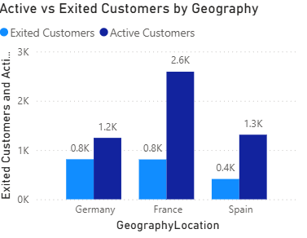
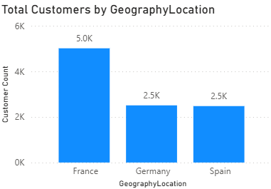
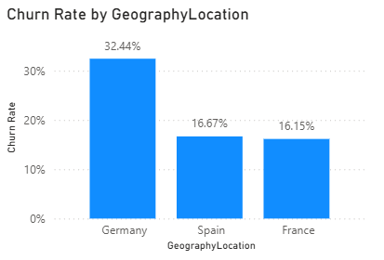
Insights :
- France has the largest customer base with approximately 5,000 customers and also the highest number of active customers (~2.6K), indicating a strong market presence.
- Germany and Spain each have around 2,500 customers, making them smaller markets than France.
- Germany has the highest churn rate (32.44%), despite having a moderate customer base. This indicates weaker customer retention.
- France has the lowest churn rate (16.15%), showing better customer loyalty and retention.
- Spain has a churn rate of 16.67%, which is close to France and significantly lower than Germany.
Recommendations :
- Prioritize customer retention initiatives in Germany, where churn is the highest.
- Analyse the factors contributing to France's lower churn and replicate successful strategies in other regions.
- Continue investing in France due to its large active customer base.
- Develop targeted marketing and customer engagement programs in Germany to improve retention and reduce customer attrition.

- Risk Management Assessment: Based on customer profiles, which demographic segments appear to pose the highest financial risk to the bank, and why?
Approach :
Customer demographic characteristics were analyzed using Age Group, Gender, Credit Score, Average Balance, and Churn Rate to identify which customer segments pose the highest financial risk to the bank.
DAX Queries :
- Average Credit Score = AVERAGE(Bank_Churn[CreditScore])
- Average Balance = AVERAGE(Bank_Churn[Balance])
Visualizations :
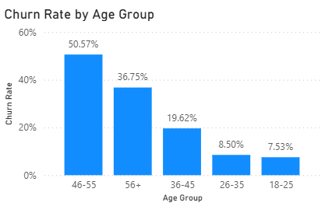
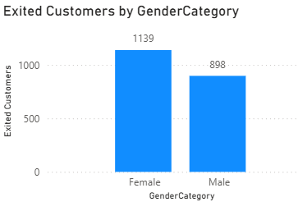
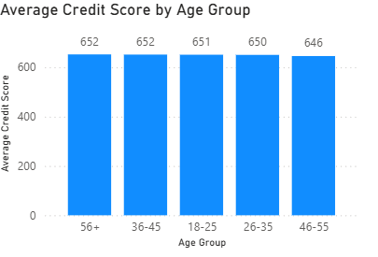
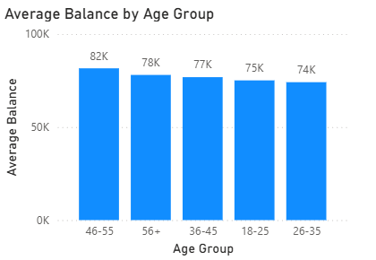
Insights :
- Customers aged 46–55 represent the highest financial risk, with the highest churn rate of 50.57%.
- This age group also has the highest average account balance (82K), meaning the bank risks losing customers who hold larger deposits.
- The 46–55 age group has the lowest average credit score (646) among all age groups, indicating comparatively higher credit risk.
- Female customers recorded 1,139 exited customers, compared with 898 male customers, suggesting that female customers experienced slightly higher attrition in this dataset.
Recommendations :
- Prioritize retention programs for customers aged 46–55, as they combine high balances with high churn risk.
- Provide personalized financial products, loyalty rewards, and relationship management for high-value customers in this segment.
- Monitor customers with relatively lower credit scores more closely to reduce financial risk.
- Conduct additional analysis to understand why female customers are exiting at a higher rate and design targeted retention campaigns if needed.

- Customer Tenure Value Forecast: How would you use the available data to model and predict the lifetime (tenure) value in the bank of different customer segments?
Approach :
- Customer Lifetime Value (CLV) can be estimated by analysing customer tenure along with average balance, credit score, and active membership status.
- Customers who stay longer, maintain higher balances, and remain active are expected to generate greater long-term value for the bank.
Visualizations :
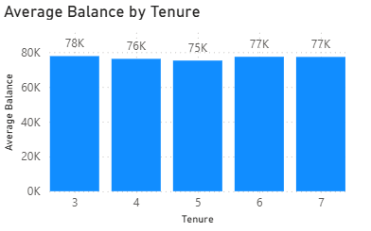
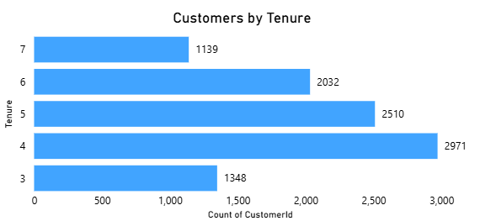
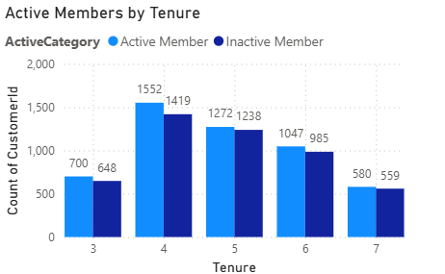
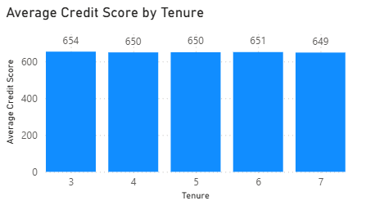
Insights :
- Customers with 3–7 years of tenure maintain a consistently high average balance of ₹75K–₹78K, indicating stable financial value.
- The largest customer segment has a tenure of 4 years (2,971 customers), followed by 5 years (2,510 customers), showing that most customers have medium-term relationships with the bank.
- Active members slightly outnumber inactive members across all tenure groups, suggesting good customer engagement and retention.
- The average credit score remains stable around 649–654 across all tenure groups, indicating consistent credit quality regardless of tenure.
Recommendations :
- Prioritize retention programs for customers with 4–6 years of tenure, as they represent the largest and most valuable customer segment.
- Offer personalized products, loyalty rewards, and premium banking services to customers with higher tenure to maximize their lifetime value.
- Develop a Customer Lifetime Value (CLV) prediction model using Tenure, Balance, Credit Score, Active Membership, and Number of Products to identify high-value customers and support targeted marketing campaigns.

- Marketing Campaign Effectiveness: How could you assess the impact of marketing campaigns on customer retention and acquisition within the dataset? What extra information would you need to solve this?
Approach :
- Although the dataset does not contain campaign-specific information, customer segments with high churn risk or high engagement can be identified.
- These segments would be the primary targets for future marketing campaigns.
- By analysing customer behaviour, demographics, product usage and churn, the bank can estimate where marketing efforts are likely to have the greatest impact.
Visualizations :
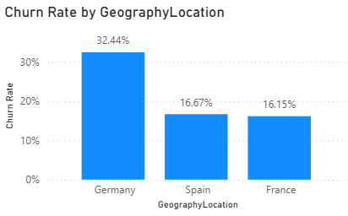
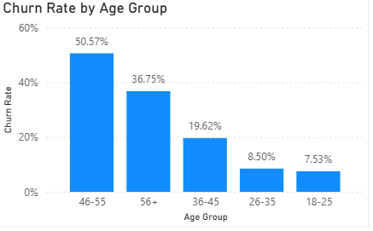
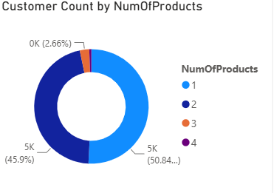
Insights :
- Churn Rate by Geography – Identifies regions where customer retention campaigns should be prioritized.
- Churn Rate by Age Group – Highlights age segments with the highest churn risk for targeted retention efforts.
- Customer Count by Number of Products – Identifies customers with only one product who are the best candidates for cross-selling campaigns.
- Germany has the highest churn rate (32.44%), making it the top priority for customer retention initiatives.
- Customers aged 46–55 and 56+ exhibit the highest churn rates (50.57% and 36.75%), suggesting these age groups require targeted engagement.
- Around 51% of customers own only one product, indicating significant potential for cross-selling additional banking products.
Extra Information Required
To truly evaluate campaign effectiveness, the following data would be required:
- Campaign ID/Name
- Customer ID linked to each campaign
- Campaign Date
- Marketing Channel
- Campaign Cost
- Customer Response
- Revenue generated after the campaign

Recommendations :
- Launch retention campaigns specifically targeting customers in Germany and older age groups.
- Design personalized offers (e.g., premium savings accounts, insurance, investment products) for customers owning only one product.
- Although the dataset lacks campaign information, these customer segments can be identified as the most promising targets for future marketing campaigns, enabling data-driven campaign planning.

- Customer Exit Reasons Exploration: Can you identify common characteristics or trends among customers who have exited that could explain their reasons for leaving?
Approach :
- Analyse the characteristics of exited customers using demographic and banking profile variables such as Age Group, Geography, Gender, and Number of Products.
- Since the dataset does not include an Exit Reason column, identify patterns that may explain why customers left.
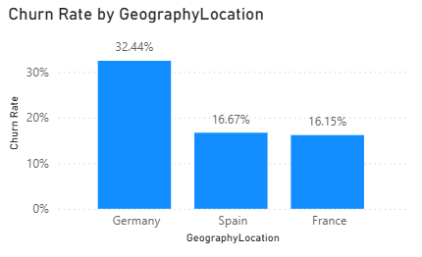
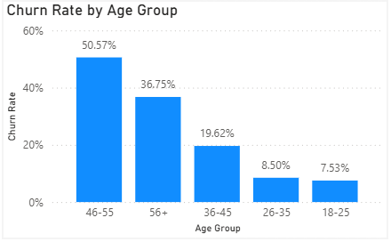
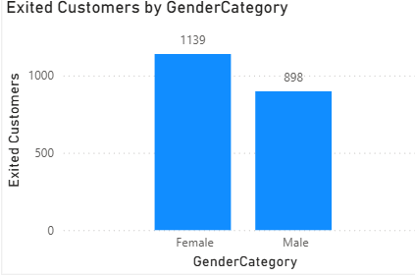
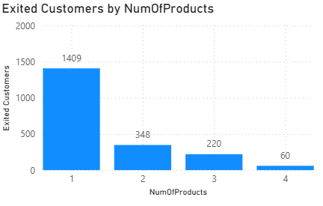
Insights :
- Germany has the highest churn rate (32.44%), indicating customers in this region are more likely to leave than those in France and Spain.
- Customers aged 46–55 have the highest churn rate (50.57%), followed by the 56+ age group (36.75%), making older customers the most vulnerable segment.
- Female customers (1,139) exited slightly more than male customers (898).
- Customers with only one banking product account for the highest number of exits (1,409), while churn decreases significantly as the number of products increases. This suggests customers with stronger product relationships are more likely to stay.
Possible reasons for leaving :
- Older customers (46–55 and 56+) may switch banks due to better financial products, retirement planning, or dissatisfaction with services.
- Germany's higher churn rate may indicate stronger competition or lower customer satisfaction in that region.
- Customers with only one banking product have weaker engagement with the bank, making them more likely to leave.
- Female customers show slightly higher exits, suggesting the bank may need more personalized products or customer engagement for this segment.
Recommendations :
- Prioritize retention campaigns for customers in Germany and those aged 46 years and above.
- Encourage customers with only one product to adopt additional banking services through personalized cross-selling offers.
- Strengthen engagement with female customers through targeted loyalty programs and personalized communication.
- Collect customer feedback and exit survey data to understand the actual reasons for churn, as the current dataset does not contain exit reason information.

- Are 'Tenure', 'NumOfProducts', 'IsActiveMember', and 'EstimatedSalary' important for predicting if a customer will leave the bank?
Approach :
- Calculated churn rate across different customer segments.
- Compared churn based on Tenure, Number of Products, Active Member Status, and Estimated Salary Groups.
- Identified which variables show the greatest difference in churn rates and are therefore stronger predictors of customer exit.
DAX Queries :
Salary Group = SWITCH(TRUE(),CustomerInfo[EstimatedSalary] <= 50000, "0-50K",
CustomerInfo[EstimatedSalary]<=100000,"50K100K",
CustomerInfo[EstimatedSalary] <= 150000, "100K150K","150K200K")

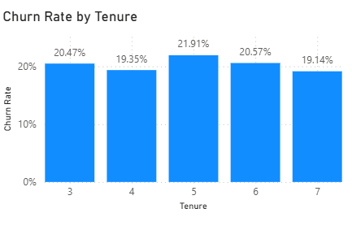
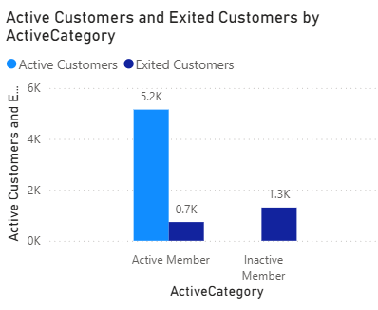
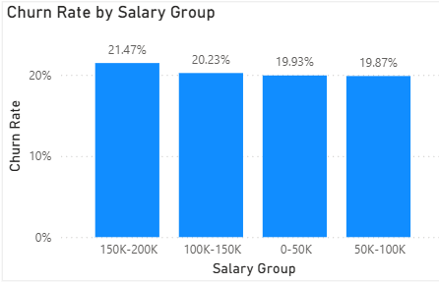
Insights :
- Tenure: Churn rate is fairly stable (around 19–22%) across tenure groups, indicating tenure has only a moderate impact on customer churn.
- Number of Products: Customers with only one product have the highest number of exits (1,409 customers). Customers with multiple products are much less likely to leave.
- Active Member Status: Inactive members have a significantly higher proportion of exited customers than active members, making customer activity one of the strongest indicators of churn.
- Estimated Salary: Churn rates across salary groups range only from 19.87% to 21.47%, showing very little variation. Salary alone is not a strong predictor of customer exit.
Observations :
- Yes, Active Member Status and Number of Products are the most important predictors of whether a customer will leave the bank.
- Tenure has a moderate influence, while Estimated Salary has minimal impact because churn rates remain almost the same across all salary groups.
Recommendations :
- Prioritize retention campaigns for inactive customers.
- Encourage customers with only one product to adopt additional banking products through cross-selling.
- Increase customer engagement with loyalty programs, personalized offers, and digital banking services.
- Do not rely heavily on Estimated Salary when predicting churn, as it contributes little to customer exit behaviour.
- Use Active Member Status and Number of Products as key features in churn prediction models to improve prediction accuracy.

- Utilize SQL queries to segment customers based on demographics and account details.
- Customer Segmentation by Age :
Select
case
when Age BETWEEN 18 AND 25 THEN '18-25'
when Age BETWEEN 26 AND 35 THEN '26-35'
when Age BETWEEN 36 AND 45 THEN '36-45'
when Age BETWEEN 46 AND 55 THEN '46-55'
else '56+'
end as Age_Group,
count(*) AS Total_Customers
from customerinfo
group by Age_Group;

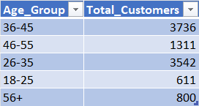

- Customer Segmentation by Geography
select
g.GeographyLocation,
count(*) as Total_Customers
from customerinfo c
join geography g
on g.GeographyID = c.GeographyID
group by g.GeographyLocation
order by Total_Customers desc;

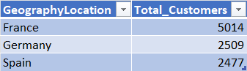

- Customer Segmentation by Number of Products
select
b.NumOfProducts,
count(*) as Total_Customers
from customerinfo c
join bank_churn b
on b.CustomerID = c.CustomerID
group by b.NumOfProducts
order by b.NumOfProducts;

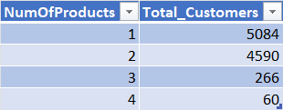

- Customer Segmentation by Credit Score
select
case
when b.CreditScore < 600 THEN 'Poor'
when b.CreditScore BETWEEN 600 AND 699 THEN 'Fair'
when b.CreditScore BETWEEN 700 AND 799 THEN 'Good'
else 'Excellent'
end as Credit_Category,
count(*) AS Customers
from customerinfo c
join bank_churn b
on b.CustomerID = c.CustomerID
group by Credit_Category;

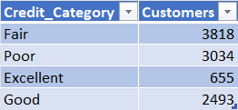

- Customer Segmentation by Balance
select
case
when b.Balance < 50000 THEN 'Low Balance'
when b.Balance BETWEEN 50000 AND 100000 THEN 'Medium Balance'
else 'High Balance'
end as Balance_Category,
count(*) as Customers
from customerinfo c
join bank_churn b
on b.CustomerID = c.CustomerID
group by Balance_Category;

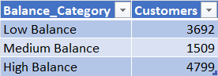

- Customer Segmentation by Active Member Status
select
case
when b.IsActiveMember = 1 THEN 'Active'
else 'Inactive'
end as Member_Status,
count(*) as Customers
from customerinfo c
join bank_churn b
on b.CustomerID = c.CustomerID
group by Member_Status;

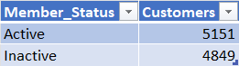

- How can we create a conditional formatting setup to visually highlight customers at risk of churn and to evaluate the impact of credit card rewards on customer retention?
Approach :
- A Power BI table was created to display customer-level information including Customer ID, Age Group, Geography, Balance, Credit Card Status, Active Member Status, and Exited.
- Conditional formatting was applied to the Exited column so that customers who have churned (Exited = 1) are highlighted in red. This allows managers to instantly identify high-risk customers.
- To evaluate the impact of credit card rewards, customer retention was compared between customers who own a credit card and those who do not by analysing churn rates across both groups.
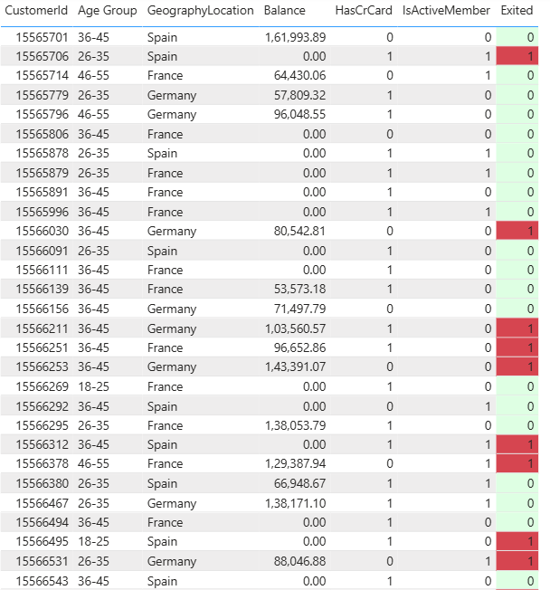
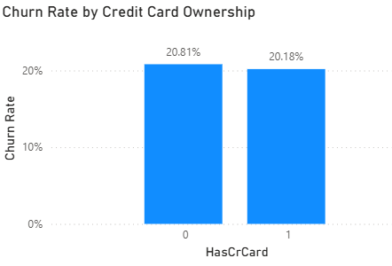
Insights :
- Conditional formatting clearly highlights churned customers, allowing managers to identify at-risk customers quickly.
- Customers without a credit card have a churn rate of 20.81%.
- Customers with a credit card have a churn rate of 20.18%.
- The difference is only 0.63%, indicating that credit card ownership alone has very little impact on customer retention.
Recommendations :
To accurately evaluate the effectiveness of credit card rewards, the bank should collect additional data such as:
- Reward points earned
- Reward points redeemed
- Cashback amount
- Reward tier (Silver/Gold/Platinum)
- Loyalty program participation
- Credit card transaction frequency
- Reward campaign participation
With these fields, the bank could compare churn rates of customers who actively use or redeem rewards versus those who do not, providing a true assessment of the impact of credit card rewards on customer retention.

- What is the current churn rate per year and overall as well in the bank? Can you suggest some insights to the bank about which kind of customers are more likely to churn and what different strategies can be used to decrease the churn rate?
Approach :
- The overall churn rate was calculated using the ratio of exited customers to the total customer base.
- Year-wise churn was analysed using the customer joining/year data to identify the churn trend over time.
- Customer characteristics such as geography, age group, number of products, and membership status were then analysed to identify the segments with the highest churn.
DAX Queries :
Churn Rate =DIVIDE(SUM('Bank Churn'[Exited]),COUNT('Bank Churn'[CustomerId]))*100
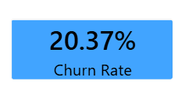
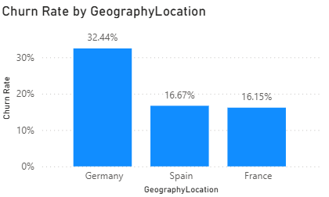
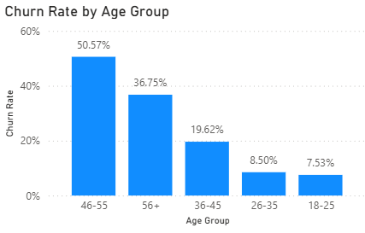
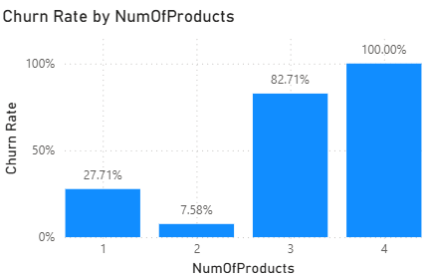
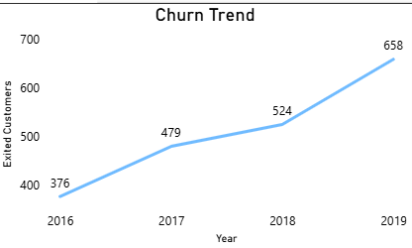
Insights :
- The bank's overall churn rate is 20.37%, meaning approximately one out of every five customers has left.
- Customer churn has increased consistently from 376 customers in 2016 to 658 customers in 2019, indicating a worsening retention trend.
- Germany has the highest churn rate (32.44%), suggesting region-specific issues.
- Customers aged 46–55 have the highest churn rate (50.57%), followed by those aged 56+ (36.75%).
- Customers with three or four products show extremely high churn rates (82.71% and 100%). Although these groups are relatively small, they require further investigation.
- Customers with only one product also have a relatively high churn rate (27.71%), indicating opportunities for cross-selling and improved engagement.
- Customers with two products are the most stable customer segment, with the lowest churn rate (7.58%).
Recommendations :
- Implement targeted retention campaigns for customers in Germany, especially those in the 46–55 and 56+ age groups.
- Investigate why customers holding three or four products are leaving despite using multiple banking services.
- Encourage customers with only one product to adopt additional banking products through personalized cross-selling offers.
- Introduce loyalty rewards, relationship managers, and exclusive benefits for high-value customers.
- Continuously monitor churn trends using Power BI dashboards and establish early-warning alerts for customers showing high churn risk.
- Conduct customer satisfaction surveys and collect feedback from customers before account closure to identify the primary reasons for churn.

- Create a dashboard incorporating all the KPIs and visualization-related metrics. Use a slicer in order to assist in selection in the dashboard.
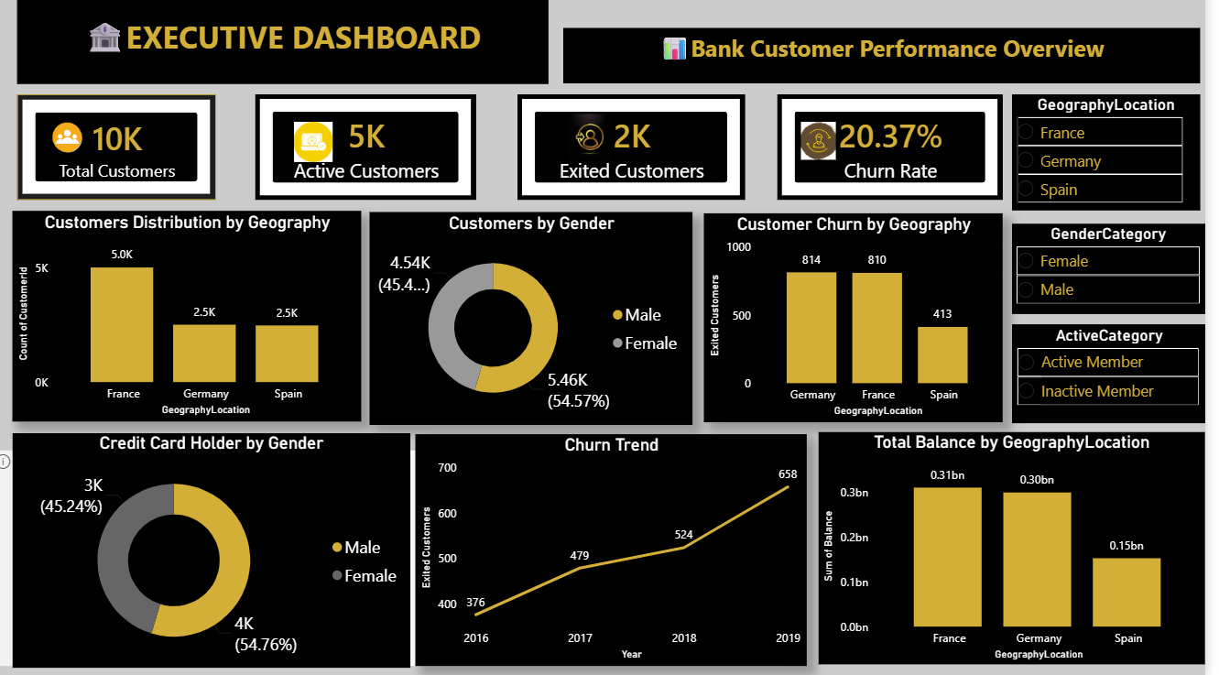
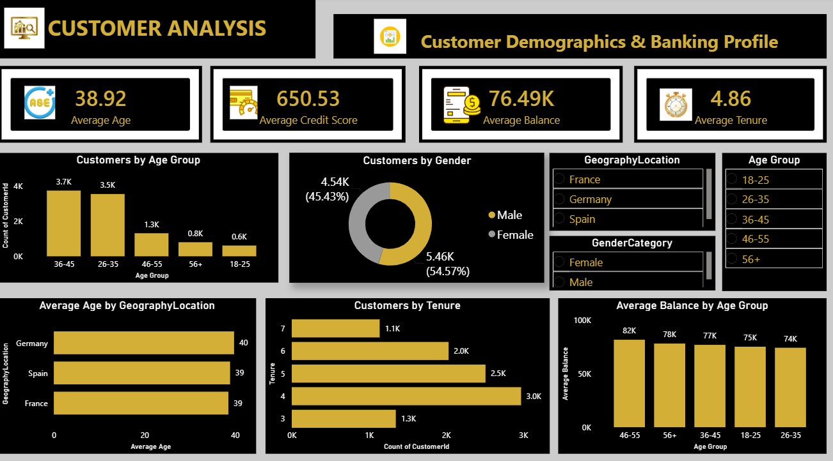
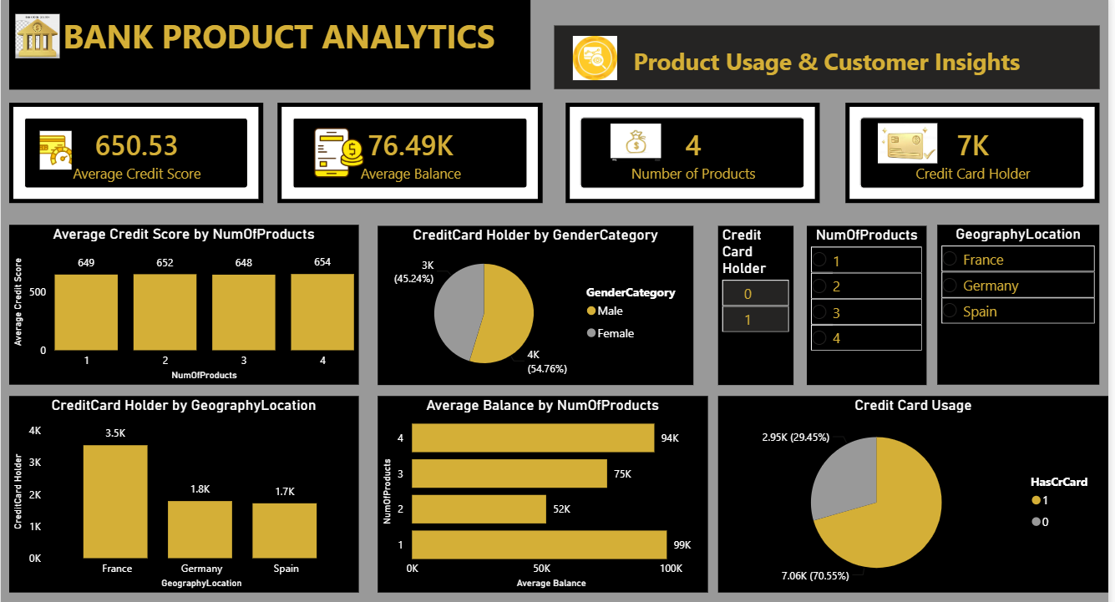
- How would you approach this problem, if the objective and subjective questions weren't given?
Approach
If no business questions were provided, I would first understand the dataset and then identify business problems through exploratory data analysis (EDA).
Steps Followed
1. Understand the Business Problem
- Identify the project's objective.
- Understand what each dataset represents.
- Learn about the business domain (banking and customer churn).
2. Explore the Data
- Review all tables, columns, and relationships.
- Check data types, missing values, duplicates, and inconsistencies.
- Create a data model (Star Schema if applicable).
3. Perform Exploratory Data Analysis (EDA)
- Calculate overall KPIs:
- Total Customers
Customer Count = COUNT(CustomerInfo[CustomerId])

- Active Customers
Active Customers = CALCULATE(COUNT(Bank_Churn[CustomerID]),Bank_Churn[IsActiveMember] = 1)

- Exited Customers
ExitedCustomers =CALCULATE(COUNT(Bank_Churn[CustomerID]),Bank_Churn[Exited] = 1)

- Churn Rate
Churn Rate = DIVIDE([Exited Customers],[Total Customers])

- Average Balance
Average Balance = AVERAGE(Bank_Churn[Balance])

- Average Credit Score
Average Credit Score = AVERAGE(Bank_Churn[CreditScore])

- Analyze customer demographics.
- Analyze customer behaviour.
- Identify trends and patterns.
4. Identify Key Business Drivers
Analyze churn by:
- Geography
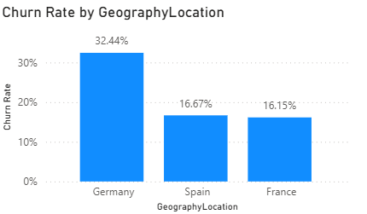
- Age Group
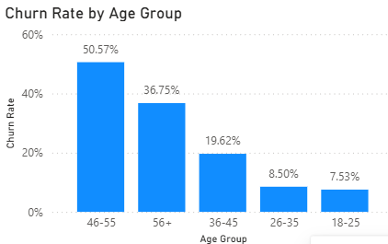
- Gender
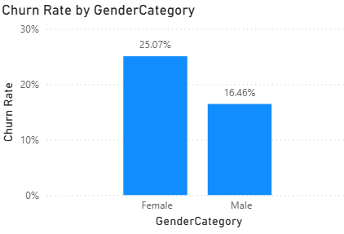
- Tenure
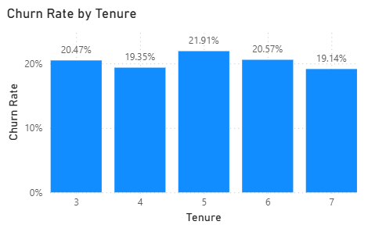
- Number of Products
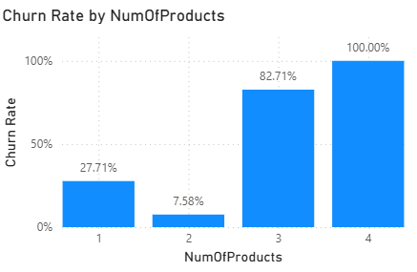
5. Form Business Questions
From the analysis, generate questions such as:
- Which customers are leaving the most?
- Which region has the highest churn?
- Does age affect churn?
- Are active members less likely to leave?
- Does the number of products influence retention?
- Which customer segments require attention?
6. Build Interactive Dashboard
Create dashboards with:
- KPI Cards
- Slicers
- Trend Charts
- Customer Segmentation
- Churn Analysis
- Drill-through pages
- Conditional Formatting
7. Generate Business Insights
Summarize:
- Key findings
- High-risk customer segments
- Factors affecting churn
- Customer behaviour patterns
8. Provide Recommendations
Suggest actionable strategies such as:
- Target high-risk customers with personalized offers.
- Improve engagement for inactive members.
- Introduce loyalty and reward programs.
- Cross-sell products to customers with only one product.
- Focus retention campaigns on high-churn regions and age groups.

- In the “Bank_Churn” table how can you modify the name of the “HasCrCard” column to “Has_creditcard”?
Steps :
- Open Power BI Desktop.
- Click Home → Transform Data.
- In Power Query Editor, select the Bank_Churn table.
- Right-click the HasCrCard column.
- Select Rename.
- Change the name from HasCrCard to Has Credit Card (or Has_creditcard, as required).
- Press Enter.
- Click Close & Apply to save the changes.
